|  |  |
| --- | --- |
| A group of people receiving food from a table  AI-generated content may be incorrect.  To supply leftover food to poor | Abstract:  The topic of supplying leftover food to the poor presents a multi-faceted solution to two pervasive global issues: hunger and food waste. This abstract outlines the process, significance, and challenges of establishing efficient food recovery and redistribution systems that connect food donors with vulnerable populations.  COLLEGE NAME : UNITED COLLEGE OF ARTS AND SCIENCE  COLLEGE CODE : brubl  TEAM ID : NM2025TMID27790  TEAM MEMBERS :  Team Leader Name : R.MANIGANDAN  Email Id : [manigandanuitcollege.com@gmail.com](mailto:manigandanuitcollege.com@gmail.com)  Team Member 1 : IMRAN.K  Email Id : [imrank0083k@gmail.com](mailto:imrank0083k@gmail.com)  Team Member 2 : JAYAKUMAR.R  Email Id : [jayakumarjayakumar0123@gmail.com](mailto:jayakumarjayakumar0123@gmail.com)  Team Member 3 : KALYAN.G  Email Id : [vishakkalyan43@gmail.com](mailto:vishakkalyan43@gmail.com) |

OBJECT:

CREATE DROP-OFF POINT OBJECT

CREATE TASK OBJECT

CREATE VOLUNTEER OBJECT

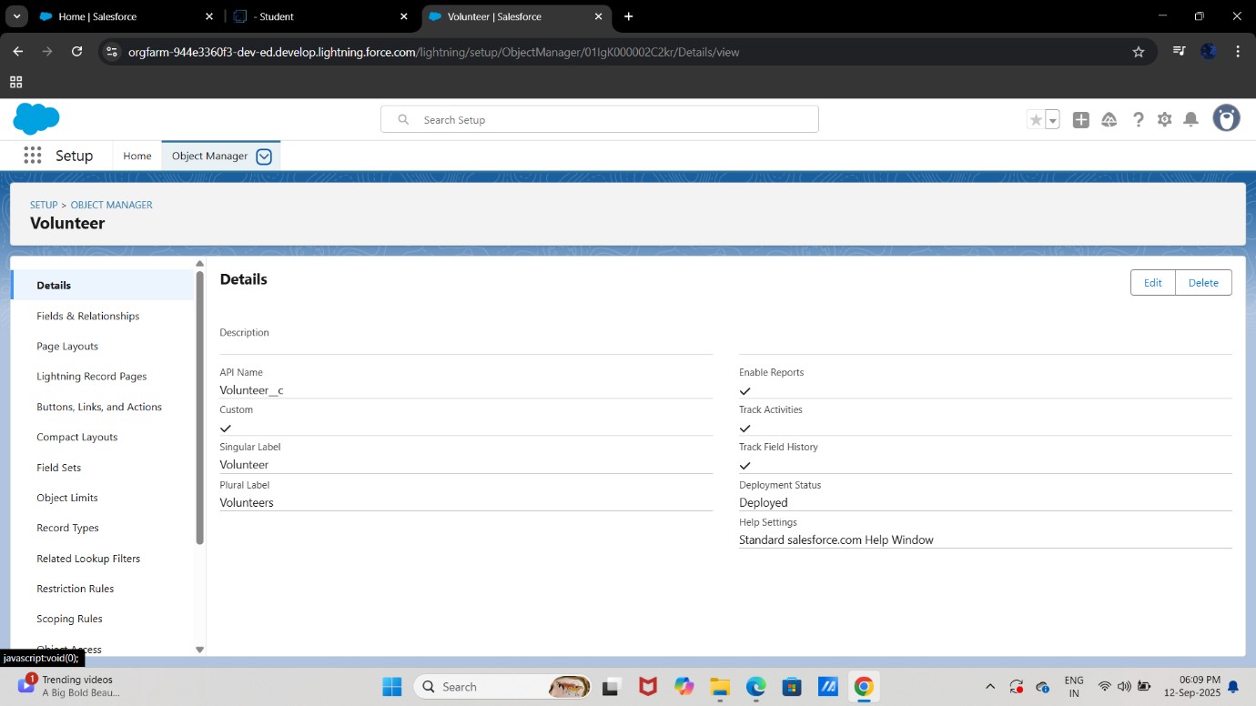

CREATE EXECUTION DEATLS OBJECT

TABS:

CREATING A CUSTOM TAB

THE LIGHTNING APP:

CREATE A LIGHTNING APP

FIELDS:

CREATION OF FIELDS IN OBJECT

CREATION OF FIELDS FOR DROP-OFF POINT OBJECT

CREATION OF FILEDS FOR THE TASK OBJECT

CREATION 0F FIRLDS FOR THE VOLUNTEER OBJECT

CREATION OF FIELDS FOR THE EXECUTION DETAILS OBJECT

CREATION OF FIELDS FOR THE EXECUTION DETAILS OBJECT

FLOWS:

CREATE FLOW TO CREATE A RECORD IN VENUE OBJECT

TRIGGER:

CREATE A TRIGGER

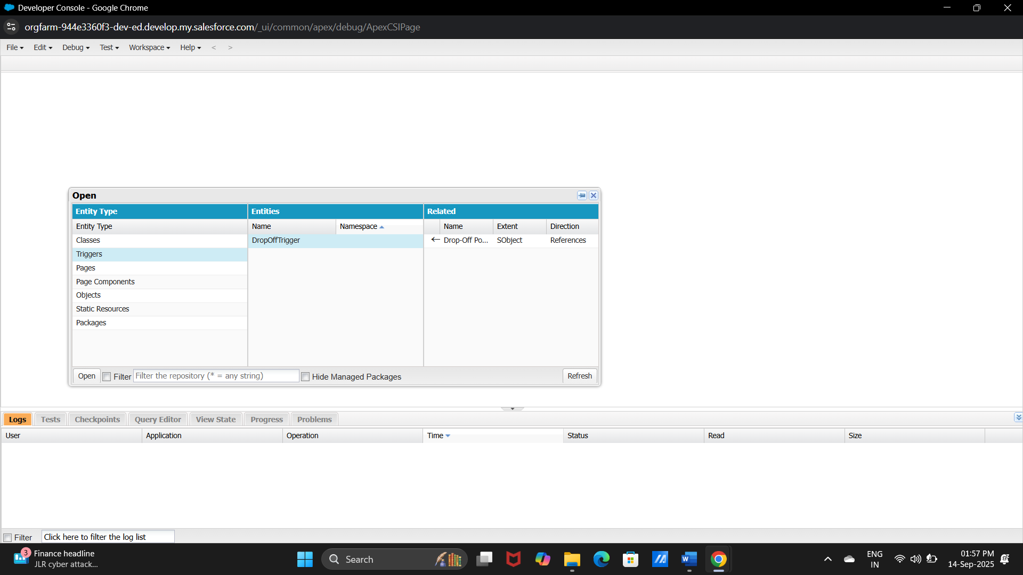

TRIGGER CODE:

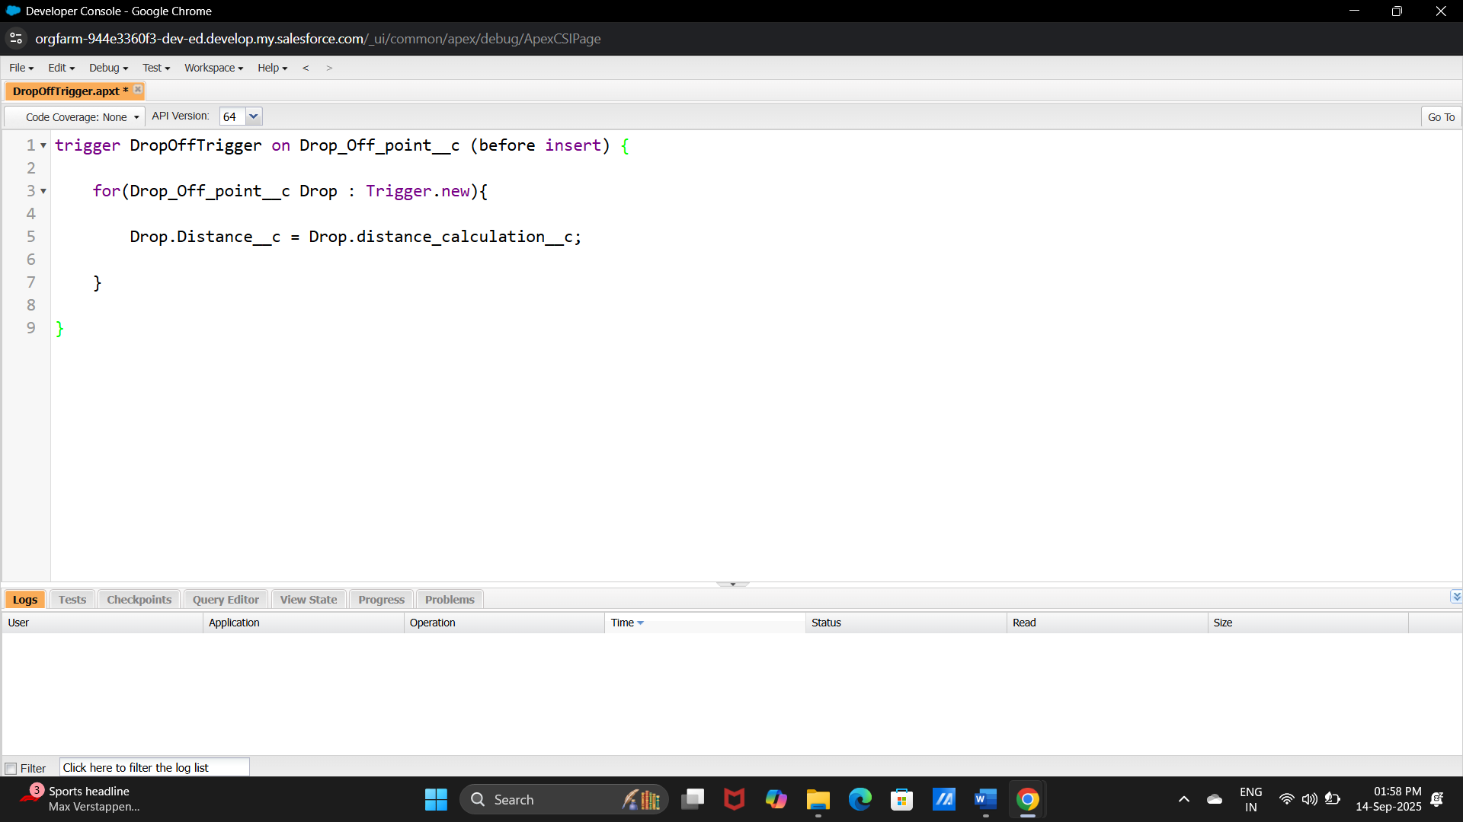

PROFILES:

CREATION OF USER1,USER2 AND USER3

PUBLIC GROUPS:

CREATION OF PUBLIC GROUP 1 AND 2

REPORT TYPES:

CREATION OF REPORT TYPES

REPORTS:

CREATION OF REPORT ON VENUE WITH DROP OFF WITH VOLUNTEER

DASHBOARDS:

ADDING A PICTURE TO THE DASHBOARD

SHARING RULES:

CREATION OF SHARING RULES

HOME PAGE:

